**PRACTICAL NO : 7**

**Model Evaluation and Hyperparameter Tuning**

**Aim:[A] Implement cross-validation techniques (k-fold, stratified, etc.) for robust model evaluation.**

**CODE:**

import numpy as np

import pandas as pd

import matplotlib.pyplot as plt

import seaborn as sns

from sklearn.model_selection import train_test_split, cross_val_score, KFold, StratifiedKFold, GridSearchCV, RandomizedSearchCV

from sklearn.ensemble import RandomForestClassifier

from sklearn.metrics import accuracy_score, classification_report

# ✅ Load the Iris dataset

from sklearn.datasets import load_iris

iris = load_iris()

X, y = iris.data, iris.target

# ✅ Split dataset into training & testing sets

X_train, X_test, y_train, y_test = train_test_split(X, y, test_size=0.2, random_state=42, stratify=y)

# ✅ Initialize the model

model = RandomForestClassifier(random_state=42)

# ✅ K-Fold Cross-Validation

kf = KFold(n_splits=5, shuffle=True, random_state=42)

kf_scores = cross_val_score(model, X, y, cv=kf, scoring='accuracy')

print(f"K-Fold Cross-Validation Accuracy: {kf_scores.mean():.4f} ± {kf_scores.std():.4f}")

# ✅ Stratified K-Fold (ensures class balance in each fold)

skf = StratifiedKFold(n_splits=5, shuffle=True, random_state=42)

skf_scores = cross_val_score(model, X, y, cv=skf, scoring='accuracy')

print(f"Stratified K-Fold Accuracy: {skf_scores.mean():.4f} ± {skf_scores.std():.4f}")

# ✅ Define hyperparameter grid

param_grid = {

'n_estimators': [50, 100, 150, 200],

'max_depth': [3, 5, 7, None],

'min_samples_split': [2, 5, 10],

'min_samples_leaf': [1, 2, 4]

}

# ✅ Grid Search CV

grid_search = GridSearchCV(model, param_grid, cv=5, scoring='accuracy', n_jobs=-1)

grid_search.fit(X_train, y_train)

print(f"Best Parameters (Grid Search): {grid_search.best_params_}")

print(f"Best Score (Grid Search): {grid_search.best_score_:.4f}")

# ✅ Randomized Search CV (more efficient for large grids)

random_search = RandomizedSearchCV(model, param_grid, n_iter=10, cv=5, scoring='accuracy', n_jobs=-1, random_state=42)

random_search.fit(X_train, y_train)

print(f"Best Parameters (Randomized Search): {random_search.best_params_}")

print(f"Best Score (Randomized Search): {random_search.best_score_:.4f}")

# ✅ Train the final model using the best parameters

best_model = grid_search.best_estimator_

y_pred = best_model.predict(X_test)

# ✅ Evaluate the final model

accuracy = accuracy_score(y_test, y_pred)

print(f"Test Accuracy: {accuracy:.4f}")

print(classification_report(y_test, y_pred, target_names=iris.target_names))

# ✅ Convert Grid Search results to DataFrame

results = pd.DataFrame(grid_search.cv_results_)

# ✅ Extract relevant columns and make a copy

heatmap_data = results[['param_n_estimators', 'param_max_depth', 'mean_test_score']].copy()

# ✅ Convert parameter values safely

heatmap_data.loc[:, 'param_n_estimators'] = heatmap_data['param_n_estimators'].astype(int)

heatmap_data.loc[:, 'param_max_depth'] = heatmap_data['param_max_depth'].astype(str) # Keep as category

# ✅ Group by to handle duplicates (take mean if needed)

heatmap_pivot = heatmap_data.groupby(['param_n_estimators', 'param_max_depth']).mean().reset_index()

# ✅ Pivot the table for heatmap

heatmap_pivot = heatmap_pivot.pivot(index='param_n_estimators', columns='param_max_depth', values='mean_test_score')

# ✅ Plot the heatmap

plt.figure(figsize=(8, 5))

sns.heatmap(heatmap_pivot, annot=True, cmap="coolwarm")

plt.title("Grid Search Accuracy Heatmap")

plt.xlabel("Max Depth")

plt.ylabel("N Estimators")

plt.show()

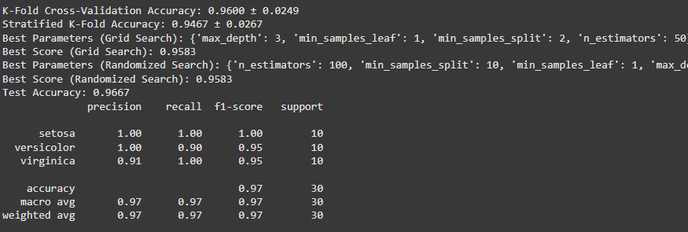

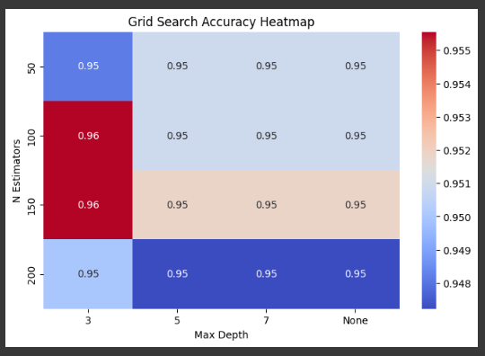

**Aim:[B] Systematically explore combinations of hyper parameters to optimize model performance.(use grid and randomized search)**

**CODE:**

import numpy as np

import pandas as pd

import matplotlib.pyplot as plt

import seaborn as sns

from sklearn.model_selection import train_test_split, GridSearchCV, RandomizedSearchCV

from sklearn.ensemble import RandomForestClassifier

from sklearn.datasets import load_iris

from sklearn.metrics import accuracy_score, classification_report

# ✅ Load dataset

iris = load_iris()

X, y = iris.data, iris.target

# ✅ Split data

X_train, X_test, y_train, y_test = train_test_split(X, y, test_size=0.2, random_state=42, stratify=y)

# ✅ Define hyperparameter grid

param_grid = {

'n_estimators': [50, 100, 150, 200],

'max_depth': [3, 5, 7, None],

'min_samples_split': [2, 5, 10],

'min_samples_leaf': [1, 2, 4]

}

grid_search = GridSearchCV(RandomForestClassifier(random_state=42), param_grid, cv=5, scoring='accuracy', n_jobs=-1)

grid_search.fit(X_train, y_train)

print(f"🔹 Best Parameters (Grid Search): {grid_search.best_params_}")

print(f"🔹 Best Score (Grid Search): {grid_search.best_score_:.4f}")

random_search = RandomizedSearchCV(RandomForestClassifier(random_state=42), param_grid, n_iter=10, cv=5, scoring='accuracy', n_jobs=-1, random_state=42)

random_search.fit(X_train, y_train)

print(f"🔹 Best Parameters (Randomized Search): {random_search.best_params_}")

print(f"🔹 Best Score (Randomized Search): {random_search.best_score_:.4f}")

best_model = grid_search.best_estimator_

y_pred = best_model.predict(X_test)

accuracy = accuracy_score(y_test, y_pred)

print(f"✅ Test Accuracy: {accuracy:.4f}")

print(classification_report(y_test, y_pred, target_names=iris.target_names))

results = pd.DataFrame(grid_search.cv_results_)

# ✅ Extract relevant columns

heatmap_data = results[['param_n_estimators', 'param_max_depth', 'mean_test_score']].copy()

# ✅ Convert parameter values safely

heatmap_data.loc[:, 'param_n_estimators'] = heatmap_data['param_n_estimators'].astype(int)

heatmap_data.loc[:, 'param_max_depth'] = heatmap_data['param_max_depth'].astype(str)

# ✅ Handle duplicates by averaging

heatmap_pivot = heatmap_data.groupby(['param_n_estimators', 'param_max_depth']).mean().reset_index()

heatmap_pivot = heatmap_pivot.pivot(index='param_n_estimators', columns='param_max_depth', values='mean_test_score')

# ✅ Plot the heatmap

plt.figure(figsize=(8, 5))

sns.heatmap(heatmap_pivot, annot=True, cmap="coolwarm")

plt.title("Grid Search Accuracy Heatmap")

plt.xlabel("Max Depth")

plt.ylabel("N Estimators")

plt.show()

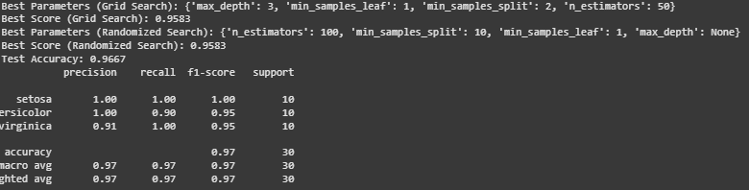

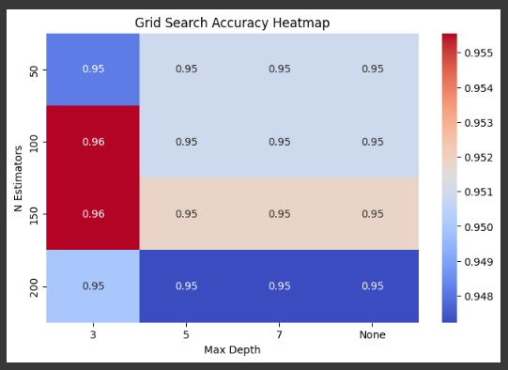

**PRACTICAL NO : 8**

**Bayesian Learning**

**Aim:[A] Implement Bayesian Learning using inferences.**

**CODE:**

import numpy as np

import pandas as pd

import matplotlib.pyplot as plt

import seaborn as sns

from sklearn.model_selection import train_test_split

from sklearn.naive_bayes import GaussianNB

from sklearn.datasets import load_iris

from sklearn.metrics import accuracy_score, classification_report, confusion_matrix

# ✅ Load dataset

iris = load_iris()

X, y = iris.data, iris.target

# ✅ Split data

X_train, X_test, y_train, y_test = train_test_split(X, y, test_size=0.2, random_state=42, stratify=y)

# ✅ Train Naïve Bayes model (Bayesian Inference)

model = GaussianNB()

model.fit(X_train, y_train)

# ✅ Make Predictions

y_pred = model.predict(X_test)

# ✅ Model Evaluation

accuracy = accuracy_score(y_test, y_pred)

print(f"✅ Accuracy: {accuracy:.4f}")

print("\n🔹 Classification Report:")

print(classification_report(y_test, y_pred, target_names=iris.target_names))

# ✅ Confusion Matrix

conf_matrix = confusion_matrix(y_test, y_pred)

plt.figure(figsize=(6, 4))

sns.heatmap(conf_matrix, annot=True, cmap="Blues", fmt="d", xticklabels=iris.target_names, yticklabels=iris.target_names)

plt.xlabel("Predicted Label")

plt.ylabel("True Label")

plt.title("Confusion Matrix for Naïve Bayes")

plt.show()

# ✅ Posterior Probabilities for Inference

sample = X_test[0].reshape(1, -1) # Taking one sample for inference

probs = model.predict_proba(sample)

print(f"🔹 Posterior Probabilities for Sample {sample}:")

for class_label, prob in zip(iris.target_names, probs[0]):

print(f" {class_label}: {prob:.4f}")

